**What is Automated Process Control?**

Use of machines and equipment for performing physical and mental operations in a production process in place of human being

Automation has been used since the time of ancient Egypt and Greece (more than 2000 years ago). For instance, automation was used to open the doors of temples. In order to achieve this, a sacrificial fire was lit, increasing the temperature of the air in a vessel below and displacing water from this storage vessel via a pipe to a container connected by a chain drive to the doors. When the fire was extinguished, the water was drawn back into the storage vessel and the counterweights closed the doors.

It is a system of doing work where material handling, production process and product designs are integrated through mechanism of thoughts and efforts to achieve a set regulating & controlling system.

It is the result of Industrialization to increase productivity & to achieve consistent quality products

It can be done at various levels of manufacturing system

* Handling of raw materials, semi-finished goods or finished goods.
* During production process (efficient machines are used).
* In Inspection and Quality control operations.

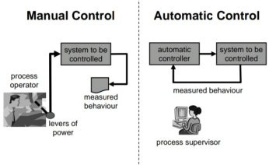

**Basic purpose of AUTOMATION in industry is:**

* To increase Productivity.
* Improve quality of products & to reduce waste.
* To reduce the costs.
* For safe handling of Hazardous substances.
* To take heavy work from workers.

Regulation is a major consideration for Automation as it ensures compliance with safety considerations and guidelines.

ADVANTAGES:

* 2 people clipped this slide
* It provides better quality of goods and service.
* It causes reduction in direct labor costs.
* There is effective control on operation.
* There is greater accuracy, more output and greater speed.
* Presentation Courses
* The production planning and control is to be done in the beginning only
* The working conditions can be improved
* Safety of workers is improved.
* Minimization of wastage
* The service to the consumer is enhanced.
* The quality of product improves as human input is minimized.

DISADVANTAGES:

* Huge capital investment is required.
* The maintenance cost is very high because maintenance labor of high caliber is required.
* It can create unemployment.
* Continuous power supply is required.
* Large inventories are required.
* Any breakdown, anywhere would lead to complete shutdown.
* Requires highly skilled manpower.
* There are restrictions in designing and construction of the building.

**Classification of industrial and laboratory automation:**

*PROCESS AUTOMATION* deals mainly with handling of raw materials in forms such as liquids or powders. Egg in oil refinery, oil & gas and chemical industries.

*DISCRETE AUTOMATION* essentially deals with assembly of parts requiring high levels of mechanical motion to produce consumer electronic products and products for the automotive industries.

**GENERAL AUTOMATIC CONTROL SYSTEM**

* In this process, the in flowing liquid is to be heated to the required temperature by the steam flowing through heating coils.
* The temperature of exit flow is affected by the processes variable such as-temperature and flow rate of the flowing liquid, temperature and flow rate of the steam, heat capacity of the fluids, and heat loss from the vessel and mixer speed.
* Liquid to be heated Mixer, Temperature to be controlled, Liquid flow out Valve, Steam Condensate Simple heat exchange process.

**Type of system in heat exchange process**

* Open loop system
* Closed loop control system
  + Feedback control system
  + Feed forward control system

***Open loop system*** is those in which information about the controlled variable (like temperature) is not used to adjust any of the system inputs to compensate for variation in the process variables.

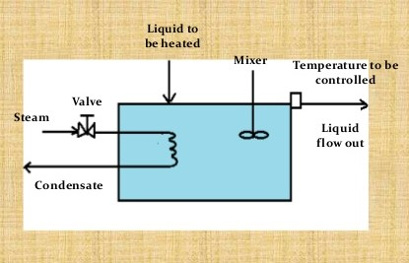

***Closed loop control system*** Is one where control variable is measure and the result of this measurement is used to manipulate one of the processes variables, such as steam flow

* **Closed loop feedback system**
* In this system, information about the controlled variables is feedback as the basis for control of a process variable by a human operator (manual control) or by use of Instruments (automatic control).
* In *manual control system* an operator periodically measures the temperature of liquid. If for example, the temperature is below the desired value, he increases the steam flow by opening the valve slightly.
* For *automatically controlled system* a temperature sensitive device is used to produce a signal proportional to the measured temperature. This signal is feed to controller which compare it with a preset desired valve (set point). If differences exist, the controller changes the opening of the steam control valve to correct the temperature

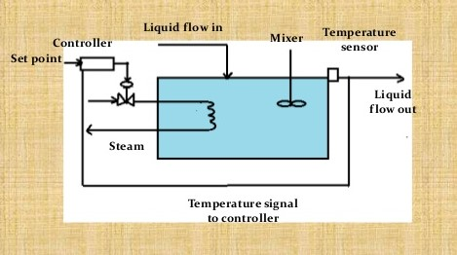

* **Closed loop feed forward control**
* In this process disturbances are measured and compensated without waiting for a change in the controlled variable to indicate that a disturbance has occurred.
* This type of control is useful when the final controlled variable cannot be used.

**PROCESS MEASUREMENTS**

INSTRUMENTS FOR MEASURING VACUUM

* Simple manometers
* Compression gauges
* Thermal gauges
* Ionization gauges
* Diaphragm gauges

INSTRUMENTS FOR TEMPERATURE

* Thermo Couples
* Resistances Thermometers
* Filled-In Thermometers
* Bimetal Thermometer
* Liquid-in-glass Thermometer
* Pyrometer

**A QUICK OVERVIEW OF MIDSEM REPORT**

**Thermal Power Generation Plant**

* Thermal power generation plant or thermal station is that the most conventional source of electrical power. Thermal station is additionally referred as coal thermal station and turbine station.
* In thermal power plants, the warmth energy obtained from combustion of solid fuel (mostly coal) is employed to convert water into steam, this steam is at air mass and temperature.
* This steam is employed to rotate the turbine blade turbine shaft is connected to the generator. The generator converts the kinetic energy of the turbine impeller into electric energy.

### We have discussed the following topics *Concept behind Thermal Power Station,**Line Diagram of Power Plant, Advantages and Disadvantages of Thermal Power Plant.*

**Power Plant Cycles**

* A thermal power plant works on the principle that heat is released by burning fuel which produces (working fluid) (steam) from water. The steam so produced runs the turbine coupled to generator which produces electricity.
* A working fluid goes through a repetitive cycle change and this cyclic change involving heat and work is understood as thermodynamic cycle. Thus, a thermodynamic cycle may be a series of operations, involving a heat source, a heat receiver, a machine and dealing substance.

**Types of Power Plant Cycles**

Thermal power plants, in general, may work on

Vapor and Gas Power cycles

Vapor Power cycles can be classified as:

(i) Rankine cycle

(ii) Reheat cycle

(iii) Regenerative cycle

(iv) Binary vapor cycle

Gas Power Cycle can be classified as follows:

(i) Otto cycle

(ii) Diesel cycle

(iii) Dual combustion cycle

(iv) Gas turbine cycle

We discussed following topics too, *Rankine Cycle, Reheat Cycle, Advantages and Disadvantages of Reheating Cycle, Regenerative Cycle and its Advantages & Disadvantages.*

**Efficiency of Thermal Power Plants**

Overall efficiency of a thermal power plant is calculated as the ratio of heat equivalent of electric power and heat produced due to fuel combustion in the furnace.



Although many factors affect the heat transfer cycle and efficiency, the major ones are:

* Boiler Efficiency
* Cycle Efficiency
* Turbine Efficiency
* Generator Efficiency

A typical Thermal Power Plant efficiency is quite low. Generally, it ranges between 25 to 30%, and in extremely rare cases it is 40%.

**Overview of TPP Performance Report**

We were provided an Opportunity Identification Report by the Industry mentor which detailed the current performance of the UTCL Vikram Cement Works Power Plant and identified opportunities for improvement and increasing efficiency. The report was based on a performance study conducted by ABB where plant performance data was recorded and analyzed.

**HOW ABB CONDUCTED THE STUDY**

Before conducting a detailed study, a baseline for current plant performance was established. This was done to compare it against the new performance data that would be recorded after the suggested improvements were implemented. The baseline also helped in finding any deviations in design performance values for plant equipment and machinery.

ABB’s performance calculation software module was used to determine actual plant performance. The software assumes a fuel composition of 100%Pet Coke (with calorific value of 8182 kcal/kg), mixed with 30-40% limestone used as boiler feed. Control logic software was also used to track how present controls were configured.

The actual plant performance was then recorded for 2 different units of the plant to establish a baseline.

**CONCLUSION BASED ON THE STUDY:**

The performance report suggested over a dozen performance improvement opportunities for UTCL Vikram Cement Works Power Plant. The report also suggested improvements for few control logics along with their prospective benefits.